Week 4 – Mandatory Hands-On Exercises

1. Spring Boot Web Project Setup
2. pom.xml

<dependencies>

<dependency>

<groupId>org.springframework.boot</groupId>

<artifactId>spring-boot-starter-web</artifactId>

</dependency>

<dependency>

<groupId>org.springframework.boot</groupId>

<artifactId>spring-boot-devtools</artifactId>

<scope>runtime</scope>

</dependency>

</dependencies>

1. SpringLearnApplication.java

package com.cognizant.springlearn;

import org.slf4j.Logger;

import org.slf4j.LoggerFactory;

import org.springframework.boot.SpringApplication;

import org.springframework.boot.autoconfigure.SpringBootApplication;

@SpringBootApplication

public class SpringLearnApplication {

private static final Logger LOGGER = LoggerFactory.getLogger(SpringLearnApplication.class);

public static void main(String[] args) {

LOGGER.info("START");

SpringApplication.run(SpringLearnApplication.class, args);

LOGGER.info("END");

}

}

1. application.properties

logging.level.root=info

logging.level.com.cognizant=debug

server.port=8080

Output:

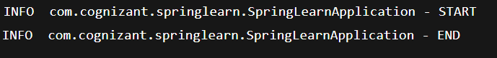

1. Load Country from Spring Configuration XML
2. Creating Country class

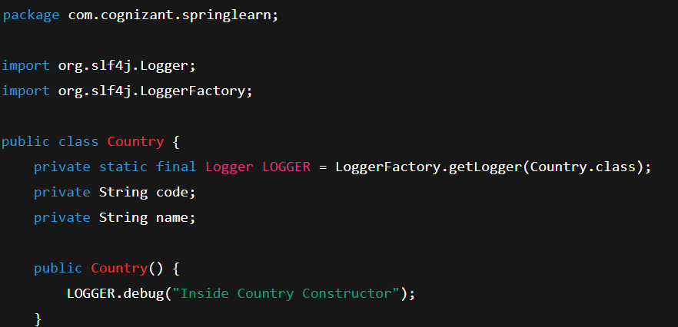

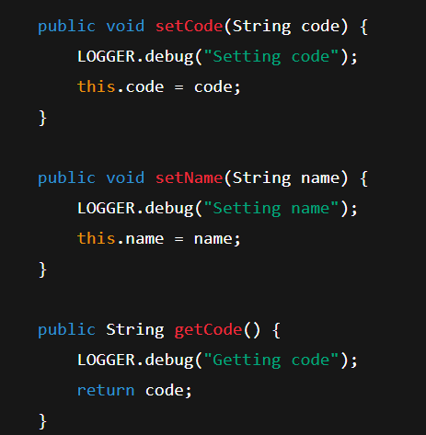

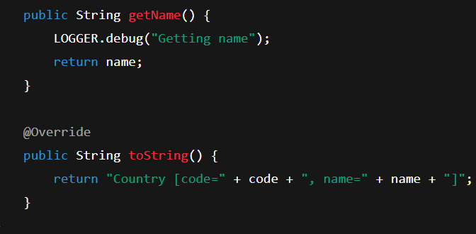

1. country.xml

<?xml version="1.0" encoding="UTF-8"?>

<beans xmlns="http://www.springframework.org/schema/beans"

xmlns:xsi="http://www.w3.org/2001/XMLSchema-instance"

xsi:schemaLocation="http://www.springframework.org/schema/beans

https://www.springframework.org/schema/beans/spring-beans.xsd">

<bean id="country" class="com.cognizant.springlearn.Country">

<property name="code" value="IN" />

<property name="name" value="India" />

</bean>

</beans>

1. SpringLearnApplication.java

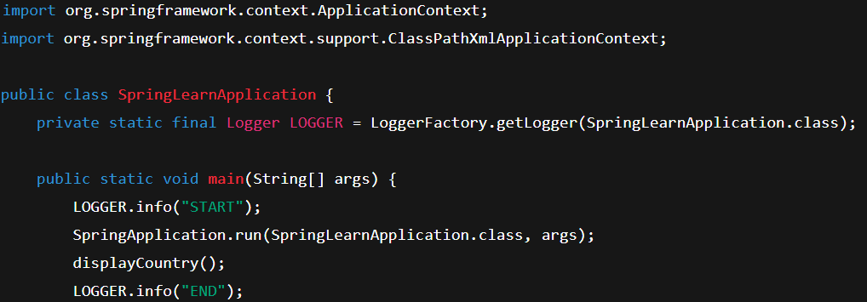

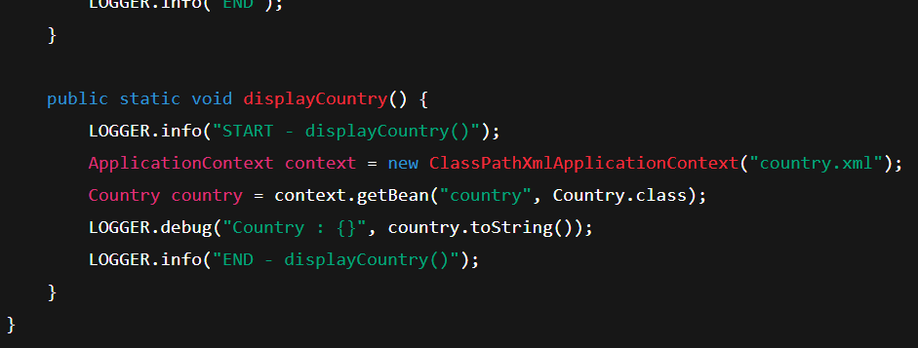

Output:

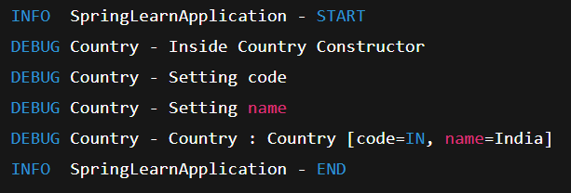

1. Hello from RESTful Web Services
2. Creating HelloController.java

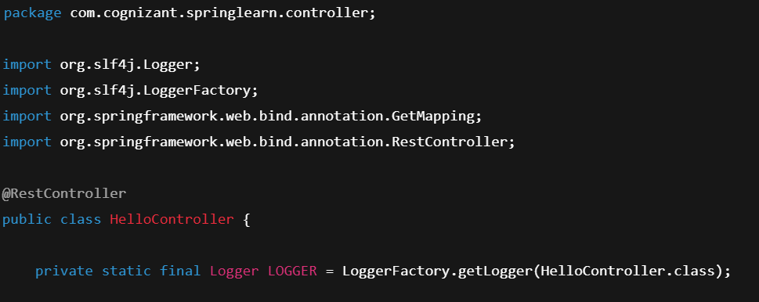

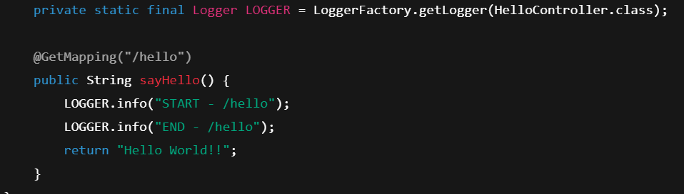

Output:



1. Country Web Service
2. Country.java

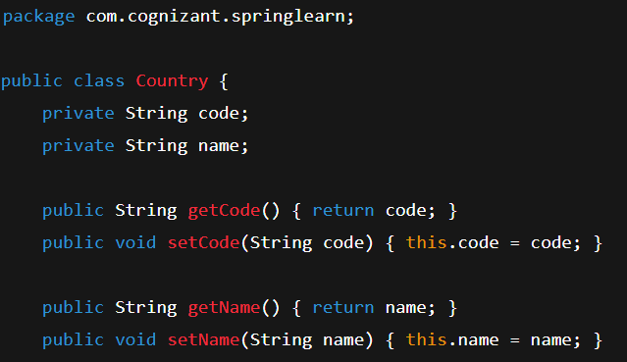

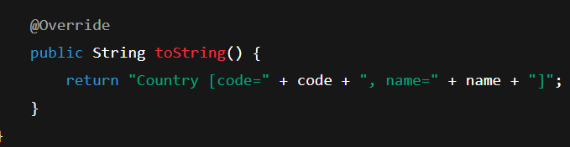

1. Country.xml

<beans xmlns="http://www.springframework.org/schema/beans"

xmlns:xsi="http://www.w3.org/2001/XMLSchema-instance"

xsi:schemaLocation="http://www.springframework.org/schema/beans

https://www.springframework.org/schema/beans/spring-beans.xsd">

<bean id="country" class="com.cognizant.springlearn.Country">

<property name="code" value="IN"/>

<property name="name" value="India"/>

</bean>

</beans>

1. Controllercountry.java

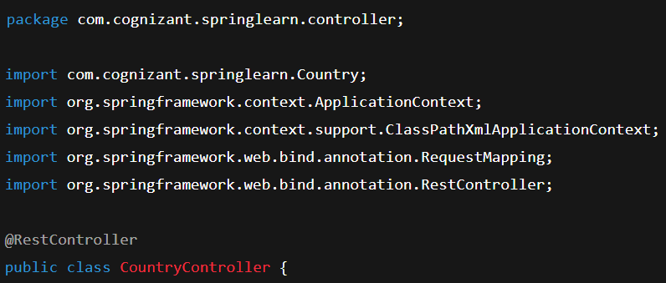

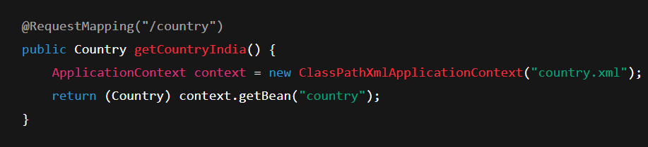

Output:

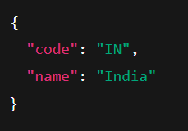

1. Get Country Based on Country code
2. Updating country.xml

<bean id="countryList" class="java.util.ArrayList">

<constructor-arg>

<list>

<bean class="com.cognizant.springlearn.Country">

<property name="code" value="IN"/>

<property name="name" value="India"/>

</bean>

<bean class="com.cognizant.springlearn.Country">

<property name="code" value="US"/>

<property name="name" value="United States"/>

</bean>

<bean class="com.cognizant.springlearn.Country">

<property name="code" value="JP"/>

<property name="name" value="Japan"/>

</bean>

</list>

</constructor-arg>

</bean>

1. Creating CountryService.java

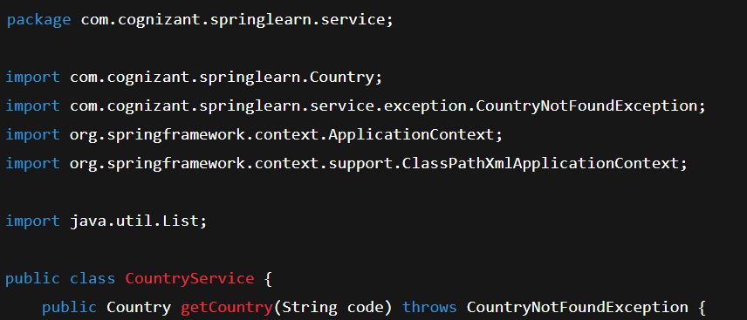

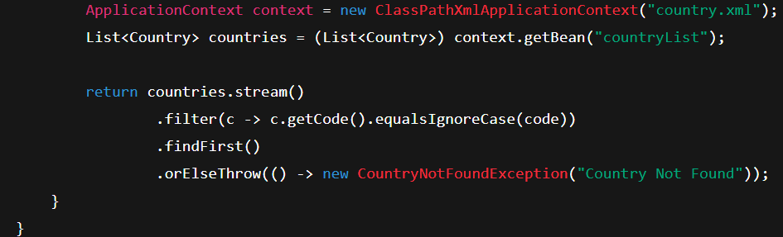

1. Adding exception – CountryNotFoundException.java

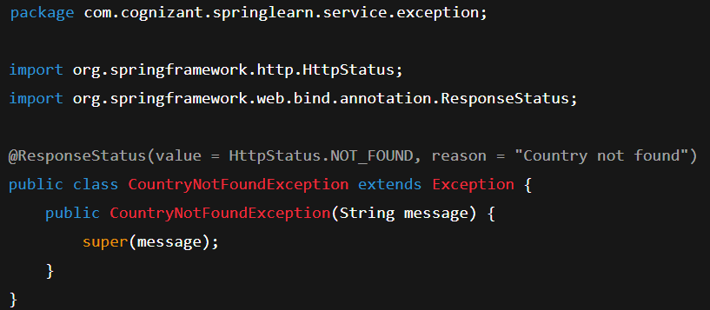

1. Update CountryController.java

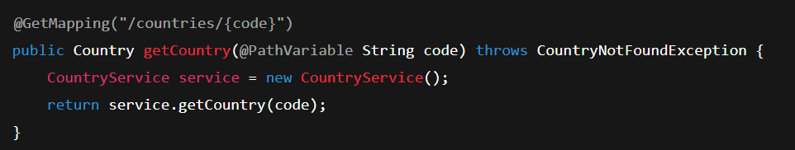

Output:

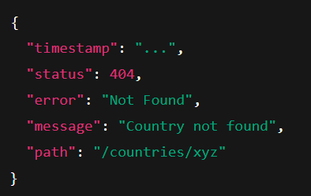

1. Create authentication service that returns JWT
2. pom.xml

<dependencies>

<dependency>

<groupId>org.springframework.boot</groupId>

<artifactId>spring-boot-starter-web</artifactId>

</dependency>

<dependency>

<groupId>org.springframework.boot</groupId>

<artifactId>spring-boot-starter-security</artifactId>

</dependency>

<dependency>

<groupId>io.jsonwebtoken</groupId>

<artifactId>jjwt</artifactId>

<version>0.9.0</version>

</dependency>

</dependencies>

1. AuthenticationController.java

package com.cognizant.springlearn.controller;

import io.jsonwebtoken.Jwts;

import io.jsonwebtoken.SignatureAlgorithm;

import io.jsonwebtoken.JwtBuilder;

import org.slf4j.Logger;

import org.slf4j.LoggerFactory;

import org.springframework.web.bind.annotation.\*;

import java.util.Base64;

import java.util.Date;

import java.util.HashMap;

import java.util.Map;

@RestController

public class AuthenticationController {

private static final Logger LOGGER = LoggerFactory.getLogger(AuthenticationController.class);

@GetMapping("/authenticate")

public Map<String, String> authenticate(@RequestHeader("Authorization") String authHeader) {

LOGGER.info("START");

LOGGER.debug("Authorization Header: {}", authHeader);

String user = getUser(authHeader);

String token = generateJwt(user);

Map<String, String> map = new HashMap<>();

map.put("token", token);

LOGGER.info("END");

return map;

}

private String getUser(String authHeader) {

String encodedCredentials = authHeader.substring("Basic ".length());

byte[] decoded = Base64.getDecoder().decode(encodedCredentials);

String userPass = new String(decoded);

String user = userPass.split(":")[0];

LOGGER.debug("Decoded User: {}", user);

return user;

}

private String generateJwt(String user) {

JwtBuilder builder = Jwts.builder();

builder.setSubject(user);

builder.setIssuedAt(new Date());

builder.setExpiration(new Date(System.currentTimeMillis() + 20 \* 60 \* 1000)); // 20 minutes

builder.signWith(SignatureAlgorithm.HS256, "secretkey");

return builder.compact();

}

}

1. SecurityConfig.java

package com.cognizant.springlearn.security;

import org.springframework.context.annotation.Bean;

import org.springframework.context.annotation.Configuration;

import org.springframework.security.authentication.AuthenticationManager;

import org.springframework.security.config.annotation.authentication.builders.AuthenticationManagerBuilder;

import org.springframework.security.config.annotation.web.builders.HttpSecurity;

import org.springframework.security.config.annotation.web.configuration.\*;

import org.springframework.security.crypto.bcrypt.BCryptPasswordEncoder;

import org.springframework.security.crypto.password.PasswordEncoder;

@Configuration

@EnableWebSecurity

public class SecurityConfig extends WebSecurityConfigurerAdapter {

@Override

protected void configure(AuthenticationManagerBuilder auth) throws Exception {

auth.inMemoryAuthentication()

.withUser("user").password(passwordEncoder().encode("pwd")).roles("USER")

.and()

.withUser("admin").password(passwordEncoder().encode("pwd")).roles("ADMIN");

}

@Override

protected void configure(HttpSecurity http) throws Exception {

http.csrf().disable()

.httpBasic()

.and()

.authorizeRequests()

.antMatchers("/authenticate").hasAnyRole("USER", "ADMIN")

.anyRequest().authenticated();

}

@Bean

public PasswordEncoder passwordEncoder() {

return new BCryptPasswordEncoder();

}

@Override

@Bean

public AuthenticationManager authenticationManagerBean() throws Exception {

return super.authenticationManagerBean();

} }

Output:

